Learning about Refugee Stories at Sunday School
Refugee stories are all over the Bible, and the call to welcome the stranger is repeated over and over again. Using these four stories and the lesson plan suggestions that go with them, you can introduce kids to diverse refugee experiences and help them think through what it means to love our refugee neighbours. All the books/stories in the list are current, so you should be able to find them in your local library system or bookstore.
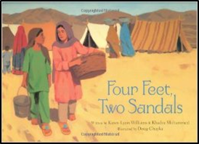 | Four Feet, Two Sandals by Karen Lynn Williams & Khadra Mohammed, illustrated by Doug Chayka (Grand Rapids, MI: Eerdmans Books for Young Readers, 2007)  Key ideas: refugee camp, Pakistan, surprising friendship, shoes, picture book  Ages: 6-12  Story debrief:  - Have you ever had to be separated from someone who is important to you? How did that feel?  - How do you think it felt for Lina and/or Feroza?  - Do you think Lina and Feroza will see each other again? When or where may that be?  - What do you think the future may be like for Lina? Feroza?  - What may change or affect their future?  - How does hope help someone dealing with a rough time?  People who flee their country and home because of fear of persecution are often called “refugees”. But it is important to remember that such people are unique individuals (just like you are unique) with their own culture, history, and life story.  - How could you help a person feel welcomed in your community?  - What would you say? What would you do?  - What could we do in our church?  (From Eerdmans guide. Link below)  Activity ideas:  - Have kids trace their feet on paper and decorate them. Then turn them upside down on the floor with everyone else’s and take turns trying to find matches. If the two turned up are not a match, turn them down again in the same spot and give the next child a turn to try to find a match, remembering where past sandals were.  - Could also make Henna designs on hands (for older kids, it can be real; for younger kids, on paper).  - Some activities and questions come from Eerdman’s guide. For more lesson plan ideas: http://www.eerdmans.com/common/redesign_pdf/9780802852960_discussionguide.pdf
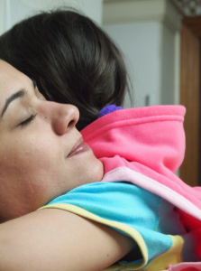 | Lulu (You can read this true, current story at http://freelulu.ca/about/.  Key ideas: home, racism, Canadian refugee system  Ages: 5 and up  (A different version of the story is available for older children/adults: http://freelulu.ca/about/family-story/)  Story debrief:  - Did you know that Jesus was a refugee when he was a kid too?  - How would you feel if you were forced to leave your home?  - What things may be happening in your city or area to “force you” you to go?  - What do you think it would be like to live in a church and not be able to go outside for a very long time? What might be fun? What might not be so fun?  Activity ideas:  - Write a letter or card to Lulu.  - Make a poster telling your church congregation about Lulu.  For more background information, you can listen to an interview with Lulu’s parents here: http://www.cbc.ca/thecurrent/episode/2014/06/04/pusuma-family-facing-deporation-to-hungary/
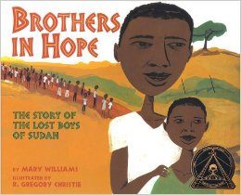 | Brothers in Hope: The Story of the Lost Boys of Sudan by Mary Williams & R. Gregory Christie, illustrated by Gregory Christie (Lee & Low Books, 2005)  Key ideas: Sudan, refugee camp, orphan boys, picture book  Ages: 6-12  Story debrief:  - (before reading) Look at the front cover… Why do you think these boys are lost?  - Have you ever been lost? How did you feel? What did you do? Who helped you?  - What is a “refugee”? What causes people to become refugees?  - Why did Garang decide to come to the United States? Why might it be hard for a Lost Boy to adjust to life in America or Canada?  - Some questions from classroom guide by Mary Williams: http://www.teachingbooks.net/media/pdf/LeeandLow/brothers.pdf  For older children only: Look at pictures that kids drew from bombed villages in Sudan—suggested images for use: Nur, Magda, Mostafa)  About the drawings: http://www.hrw.org/legacy/photos/2005/darfur/drawings/introduction.htm  Activity ideas:  - Draw a picture of one thing you would take with you if you had to leave your home.  - Trace out the Lost Boys’ route on a map of East Africa while listening to Sudanese music (e.g. Emmanuel Kembe, Reflections BYG, Yaba Angelosi)  - Draw a line down a piece of paper, and draw two pictures: life for these brothers in Sudan, and life for them if they lived here.  - With the group, make a list of all the things these brothers may have to get used to if they came to live in Toronto.
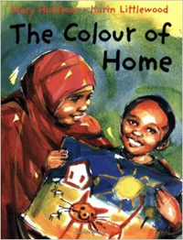 | The Colour of Home by Mary Hoffman, illustrated by Karin Littlewood (Great Britain: Frances Lincoln, 2002)  Key Ideas: refugee child, a new home, struggle, Somalian, Great Britain, picture book  Ages: 5-10  Story debrief: 5 minute video of children telling the story: https://www.youtube.com/watch?v=R4yPAArtRN0  - Have you ever been somewhere where you didn’t know many people? What did that feel like?  - How did Hassan start feeling more welcome at the end of the story?  - How could you welcome people who are new in your school or community?  Activity ideas:  - Draw a picture of one thing you would take with you if you had to leave your home.  - Make a video/skit of the story (with puppets made by kids and a simple camera and sound effects).  - Draw a picture of you and your home, using colours that tell how you feel about the place and people. Then share you picture and talk about why you used the colours you did.  - For children over 10: Identity loss simulation (from And You Invited Me In resources, page 25: http://immigration.mcc.org/system/files/And%20you%20invited%20me%20in.pdf )

More resources:
-For intergenerational educational opportunities, see pages 21-26 in “And You Invited Me In”
http://immigration.mcc.org/system/files/And%20you%20invited%20me%20in.pdf
-Hunger Banquet
-Refugee family simulation
-Identity loss simulation (p.25). Fantastic for any kids over 10

