Hurricanes Harvey and Irma
DRS and IDR
Backgrounder
Distribution Date: September 20, 2017

What are the facts about Harvey and Irma in the US?

HURRICANE HARVEY
Hurricane Harvey intensified to a Category 4 hurricane with wind gusts recorded up to 132 mph (212 kmh) and made landfall in Rockport, Texas, on August 25, 2017. The hurricane weakened, but continued to pour unprecedented amounts of water over Texas for the next 5 days. 30,000 people were displaced and more than 200,000 homes were damaged or destroyed. Governor Greg Abbott estimated that the damage after Hurricane Harvey may cost upwards of $180 billion.

The last time the United States saw a hurricane of this magnitude in 2005 when Hurricane Katrina, Rita, and Wilma all made landfall.

HURRICANE IRMA
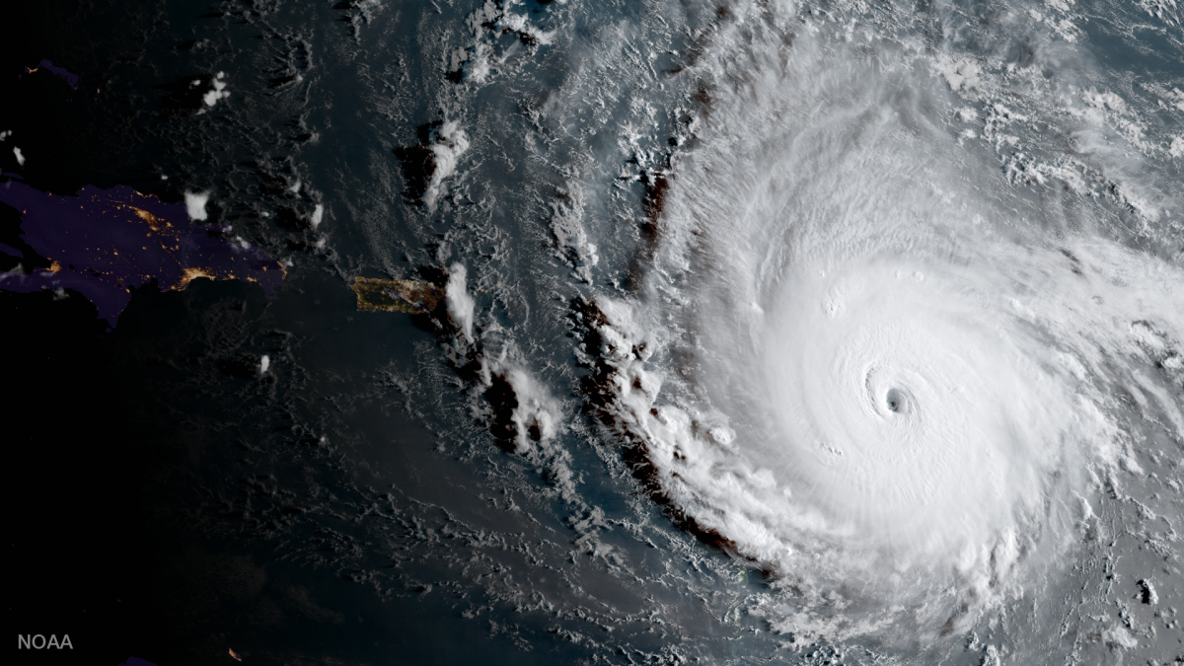
Hurricane Irma made landfall in Florida on September 10, 2017, accompanied by storm surge at least 10 feet high. The damage from Hurricane Irma is so great across Florida that the Federal Emergency Management Agency (FEMA) has already approved more than $87 million in assistance programming throughout the state of Florida. According to the governor’s office, more than 370,000 homes and business in Florida are were still without power two weeks after the storm. Major flooding was still an issue throughout the week of September 15.

How has World Renew already worked in Texas and Florida after the Hurricanes?
DRS director and regional managers have already been in Texas setting the stage for long-term recovery. DRS volunteers are helping with clean-up in Port Arthur. The same plans are being made for Florida. The first steps are to coordinate with local efforts and determine which areas are being underserved. These are the areas to which World Renew commits.

What kind of help is needed?
Homes need to be mucked out and sanitized. Communities need to determine a course of action for their recovery efforts. Spiritual and emotional care will need to be provided. Homes need to be repaired.

What kind of help will your financial support provide?
- Clean-up: Homes will need to be gutted out, floors and walls removed and treated to prevent mold growth, and all damaged items discarded. DRS volunteers provide this service.
- Organizational Capacity Building: This phase of DRS's response provides training and guidance to local recovery groups, equipping them to expand their ability to help disaster survivors over the long term.
- Unmet Needs Assessments: The damage from both hurricanes is so wide spread and overwhelming, it can be difficult for community recovery groups to know where to start. World Renew DRS unmet needs assessments volunteers will meet face-to-face with storm survivors to assess their needs and coordinate an appropriate response with local recovery groups.
- Construction Estimating: Trained volunteers make personal visits to homes to determine appropriate materials, skills and time required for repair and construction. This information is then provided to the local recovery group to use for planning the recovery process.
- Home Repairs: World Renew will send volunteers to repairing homes for survivors who, for one reason or another, are not able to repair their homes. World Renew DRS volunteers strive to make homes safe, sanitary, and secure.

Throughout all of these services, World Renew DRS acts out of the love and mercy of Jesus Christ, sharing His love and hope to hurricane survivors. This is a key part of World Renew DRS’s ministry.

For how long will World Renew DRS be responding?
World Renew DRS expects to be responding to these hurricanes for several years. Take Superstorm Sandy into consideration, five years later, DRS volunteers are still helping rebuild and World Renew DRS was still repairing homes damaged by Hurricane Katrina more than seven years after the storm.

How can you pray for the people of Texas and Florida recovering from these hurricanes and for World Renew’s work?
- Pray that emergency needs such as food, clothing, and shelter. Thank the Lord for organizations who specialize in providing mass care services.
- Pray for the spiritual and emotional well-being of survivors and first responders as they have been witness to difficult situations, have had to make difficult situations, and have suffered loss.
- Pray for World Renew staff and volunteers who are not only making plans and responding now, but will continue to share God’s hope in the months and years to come.

Did you know?
World Renew DRS has close relationships with communities in Florida and Texas already. In the last seven years World Renew has worked with 15 communities in Florida and Texas providing over 214,000 volunteer hours to help with needs assessments, clean-up, building estimating, home repairs, and capacity building.

HURRICANE IRMA: INTERNATIONAL DISASTER RESPONSE in Cuba

What are the facts?
On September 9, 2017, Irma was the first Category 5 hurricane to make landfall in Cuba since 1924. The storm caused massive destruction and widespread flooding in northern Cuba. There are reports of extensive agricultural damage, with winds and heavy rain destroying major crops. More than 2.1 million people are in urgent need of assistance.

How is World Renew’s International Response Team responding?
World Renew is working in partnership with the Cuban Council of Churches (CCC), a member of the ACT Alliance, and is well positioned to respond to the needs in the hardest hit communities. Through a project with the CCC, families in seven of the affected provinces are receiving much-needed assistance to get back on their feet and begin the journey of recovery. The current priority is to address the immediate needs for food, water, and shelter.

This project will provide:
- 800 roofs repaired
- Emergency aid for 3,000 families
- 4,100 families with food assistance
- 5,000 families with hygiene kits households receive hygiene kits
- 300 household water purification systems and installation (each one benefiting 2 households)
- Repair or installation of 15 community water systems
- Opportunities for 20,000 families to participate in post-disaster psycho-social recovery, especially children
- Rehabilitate 500 household businesses

What kind of help is needed?
The most significant immediate needs are the essentials: clean water, food, and shelter. World Renew has received over $40,000 for responding to Hurricane Irma internationally. This will allow World Renew to support the Cuban Council of Churches in the short-term, but more support is needed to meet the needs of disaster survivors in the months to come.

What kind of help will your financial support provide?

Through your support, World Renew will be able to continue partnering with the Cuban Council of Churches to provide disaster survivors with what they need most. This assistance includes repairing roofs, providing food assistance, water filters, other emergency aid, and helping small businesses recover.

How can you pray for the people of Cuba recovering from Hurricane Irma and for World Renew’s work?
- Pray that emergency needs such as food, clothing, and shelter would be met.
- Pray that God would comfort those who suddenly find their lives torn apart by grief, loss, fear, and trauma.
- Pray that local churches will demonstrate the love of Christ in Cuba to those affected by Irma.
- Pray for the Cuban Council of Churches who are not only making plans and responding now, but will continue to share God’s hope in the months and years to come.

Did you know?
Cuba and other nations nearby are preparing for the onset of Hurricane Maria, now gaining strength and heading their way.

